Compte Rendu TP N°6 PHP
Hesters Théophile

Auto insertion dans la base de donnée lors du chargement de la page
<!DOCTYPE <!DOCTYPE html>
<html>

<head>
<meta charset="utf-8">

<!-- BOOSTRAP en mode non local-->
<link rel="stylesheet" href="https://maxcdn.bootstrapcdn.com/bootstrap/4.3.1/css/bootstrap.min.css">
<script src="https://ajax.googleapis.com/ajax/libs/jquery/3.3.1/jquery.min.js"></script>
<script src="https://cdnjs.cloudflare.com/ajax/libs/popper.js/1.14.7/umd/popper.min.js"></script>
<script src="https://maxcdn.bootstrapcdn.com/bootstrap/4.3.1/js/bootstrap.min.js"></script>

</head>

<body>

</body>

</html>
<?php
/* ajout_personne.php : ajoute la personne ($nom,$prenom) dans la table Personne de la base MaBase (déjà créée) et affiche la table complète */
/* Connexion et sélection de la base */
$host = "localhost"; $user="root";
$passwd="";$base="mabase";
$table="personne";$conn = mysqli_connect($host,$user,$passwd, $base);
if (mysqli_connect_errno()){echo "Erreur de connexion a MySQL: " . mysqli_connect_errno();
exit(0);
}

/* Recherche de l'Id suivant dans la table (en supposant que Id = numéro de la ligne) */
$query = "SELECT * FROM $table";
$result = mysqli_query($conn, $query) or die("Echec de requête1");
$next_id = mysqli_num_rows($result) + 1;
mysqli_free_result($result);
/* Ajout de ($next_id,$nom,$prenom) dans la table */
$nom = "titi";
$prenom = "toto";
$query="INSERT INTO $table VALUES ('$next_id','$nom','$prenom')";
mysqli_query($conn, $query) or die("Echec de requête2");
/* Affichage complet de la table */
$query = "SELECT Nom,Prenom FROM $table";
$result = mysqli_query($conn, $query) or die("Echec de requête3");

echo "<table>\n";
while ($ligne=mysqli_fetch_array($result)) {echo "\t<tr>\n";
echo "\t\t<td>".$ligne['Nom']."</td>\n";
echo "\t\t<td>".$ligne['Prenom']."</td>\n";
echo "\t</tr>\n";}echo "</table>\n";
/* Libération du résultat */
mysqli_free_result($result);
/* Fermeture de la connexion */
mysqli_close($conn);
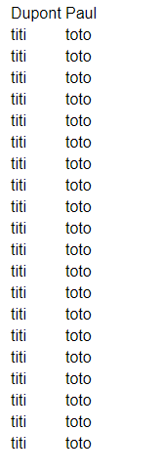
?>
Annuaire sous forme de Liste
<!DOCTYPE <!DOCTYPE html>
<html>

<head>
<meta charset="utf-8">

<body>

</body>

</html>
<?php
$host = "localhost";
$base = "MaBase";
$table = "annuaire";
$user = "root";
$password = "";

$connection = mysqli_connect($host, $user, $password, $base) or die(" ERREUR DE CONNEXION ".mysqli_connect_errno());

$query = "SELECT * FROM $table";

mysqli_query($connection, "set name utf8");

$result = mysqli_query($connection, $query) or die("ECHEC DE LA REQUETE".$query);

echo "<h3 style='text-decoration: underline;'>Liste :</h3>";
echo "<select><option selected>Id | Nom | Prénom | Adresse | Téléphone |</option>";

while ($line = mysqli_fetch_array($result, MYSQLI_NUM))
{
echo "<option>";
foreach ($line as $data)
echo "$data | ";
echo "</option>";
}

echo "</select>";

mysqli_free_result($result);
mysqli_close($connection);

?>

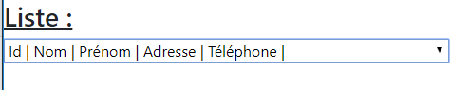
Annuaire sous forme de Tableaux

<!DOCTYPE <!DOCTYPE html>
<html>

<head>
<meta charset="utf-8">

<!-- BOOSTRAP en mode non local-->
<link rel="stylesheet" href="https://maxcdn.bootstrapcdn.com/bootstrap/4.3.1/css/bootstrap.min.css">
<script src="https://ajax.googleapis.com/ajax/libs/jquery/3.3.1/jquery.min.js"></script>
<script src="https://cdnjs.cloudflare.com/ajax/libs/popper.js/1.14.7/umd/popper.min.js"></script>
<script src="https://maxcdn.bootstrapcdn.com/bootstrap/4.3.1/js/bootstrap.min.js"></script>

</head>

<body>

</body>

</html>
<?php

$host = "localhost";
$base = "MaBase";
$table = "annuaire";
$user = "root";
$password = "";

$connection = mysqli_connect($host, $user, $password, $base) or die("Erreur de connexion au serveur MySQL : ".mysqli_connect_errno());

$query = "SELECT * FROM $table";

$result = mysqli_query($connection, $query) or die("Echec de la requête suivante :<br />".$query);

echo "<div class='container'><h3 style='text-decoration: underline;'>Tableau :</h3><table class='table table-dark table-hover'><tr><td>Id</td><td>Nom</td><td>Prenom</td><td>Adresse</td><td>Telephone</td></tr></div>";

while ($line = mysqli_fetch_array($result, MYSQLI_NUM))
{
echo "<tr>";
foreach ($line as $data)
echo "<td>$data</td>";
echo "</tr>";
}

echo "</table>";

mysqli_free_result($result);
mysqli_close($connection);

?>
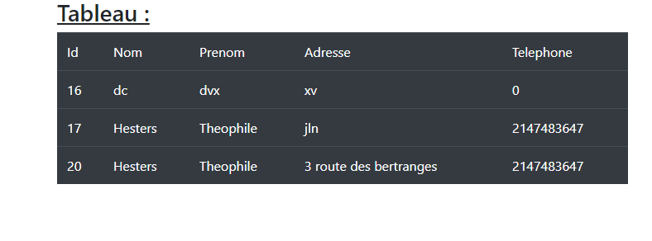

3,1,3 Menu
<!DOCTYPE html>
<html lang="en">

<head>
<title>TP6</title>
<meta charset="utf-8">
<meta name="viewport" content="width=device-width, initial-scale=1">
<!-- BOOSTRAP en mode non local-->
<link rel="stylesheet" href="https://maxcdn.bootstrapcdn.com/bootstrap/4.3.1/css/bootstrap.min.css">
<script src="https://ajax.googleapis.com/ajax/libs/jquery/3.3.1/jquery.min.js"></script>
<script src="https://cdnjs.cloudflare.com/ajax/libs/popper.js/1.14.7/umd/popper.min.js"></script>
<script src="https://maxcdn.bootstrapcdn.com/bootstrap/4.3.1/js/bootstrap.min.js"></script>
</head>

<body>

<div class="container-fluid bg-1 text-center">
<br/>
<u><h1>3.1.3 Gestions BDD </h1></u>
</div>

<div class="container">
<table class="table">
<thead>
<br />
<tr>
<th><a href="modif.php">Modifier</a></th>
<th><a href="supprimer.php">Supprimer</a></th>
<th><a href="rechercher.php">Rechercher</a></th>
<th><a href="ajouter.php">Ajouter</a></th>
<th><a href="afficher.php">Afficher</a></th> </tr>
</thead>
</table>
</div>

</body>

</html>

<?php

$host = "localhost";
$base = "MaBase";
$table = "annuaire";
$user = "root";
$password = "";

$connection = mysqli_connect($host, $user, $password, $base) or die("Erreur de connexion au serveur MySQL : ".mysqli_connect_errno());

$query = "SELECT * FROM $table";

$result = mysqli_query($connection, $query) or die("Echec de la requête suivante :<br />".$query);

echo "<br /><div class='container-fluid bg-1 text-center'><h3>Etat de la BDD</h3><br /><table class='table table-dark table-hover'><tr><td>Id</td><td>Nom</td><td>Prenom</td><td>Adresse</td><td>Telephone</td></tr></div>";

while ($line = mysqli_fetch_array($result, MYSQLI_NUM))
{
echo "<tr>";
foreach ($line as $data)
echo "<td>$data</td>";
echo "</tr>";
}

echo "</table>";

mysqli_free_result($result);
mysqli_close($connection);
?>
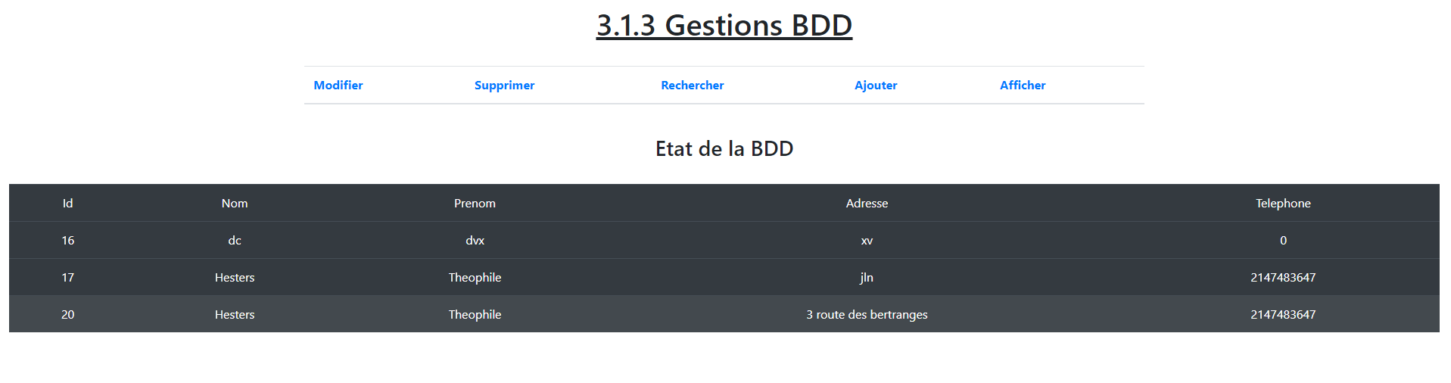
3,1,3 Modifier
<!DOCTYPE <!DOCTYPE html>
<html >

<head>
<meta charset="utf-8">
<link rel="stylesheet" href="https://maxcdn.bootstrapcdn.com/bootstrap/4.3.1/css/bootstrap.min.css">
<script src="https://ajax.googleapis.com/ajax/libs/jquery/3.3.1/jquery.min.js"></script>
<script src="https://cdnjs.cloudflare.com/ajax/libs/popper.js/1.14.7/umd/popper.min.js"></script>
<script src="https://maxcdn.bootstrapcdn.com/bootstrap/4.3.1/js/bootstrap.min.js"></script>

</head>
<body>
<header class="masthead">
<div class="overlay"></div>
<div class="container">
<div class="row">
<div class="col-lg-8 col-md-10 mx-auto">
<div class="page-heading">
<h1>MODIFICATIONS</h1>
</div>
</div>
</div>
</div>
</header>
<table class="table">
<thead>
<br />
<tr>
<th><a href="menu.php">Menu</a></th>
<th><a href="supprimer.php">Supprimer</a></th>
<th><a href="rechercher.php">Rechercher</a></th>
<th><a href="ajouter.php">Ajouter</a></th>
<th><a href="afficher.php">Afficher</a></th>
</tr>
</thead>
</table>
</div>
<form method="post" enctype="multipart/form-data" id="contact" onsubmit="setTimeout(function(){window.location.reload();},10)" enctype="multipart/form-data">
<div class="container">
<div class="row">
<div class="col-lg-8 col-md-10 mx-auto">
<form method="post" id="contact" enctype="multipart/form-data">
<div class="control-group">
<div class="form-group floating-label-form-group controls">
<label> ID à modifier</label>
<input type="text" name="id" class = "form-control"/>
<label>Nom</label>
<input type="text" name="nom1" class = "form-control"/>
<label>Prénom</label>
<input type="text" name="pre1" class = "form-control"/>
<label>Adresse</label>
<input type="text" name="adr1" class = "form-control"/>
<label>Télephone</label>
<input type="text" name="tel1" class = "form-control"/>
<br />
<button type="submit" class="btn btn-primary" name="envoi" id="sendMessageButton">Modifier</button>
</div>
</form>
</body>
</html>

<?php

$host = "localhost";
$base = "MaBase";
$table = "annuaire";
$user = "root";
$password = "";

$connection = mysqli_connect($host, $user, $password, $base) or die("Erreur de connexion au serveur MySQL : ".mysqli_connect_errno());

$query = "SELECT * FROM $table";

$result = mysqli_query($connection, $query) or die("Echec de la requête suivante :<br />".$query);

echo "<div class='container'><h3>Etat Base de Données</h3><table class='table table-dark table-hover'><tr><td>Id</td><td>Nom</td><td>Prenom</td><td>Adresse</td><td>Telephone</td></tr></div>";

while ($line = mysqli_fetch_array($result, MYSQLI_NUM))
{
echo "<tr>";
foreach ($line as $data)
echo "<td>$data</td>";
echo "</tr>";
}

echo "</table>";

mysqli_free_result($result);
mysqli_close($connection);

if (!empty ($_POST))
{
$id = $_POST['id'];
$nom = $_POST['nom1'];
$pre = $_POST['pre1'];
$adr = $_POST['adr1'];
$tel = $_POST['tel1'];
$connection = mysqli_connect($host, $user, $password, $base) or die(" ERREUR DE CONNEXION ".mysqli_connect_errno()); // Connexion à MySQL

// $query = "UPDATE annuaire SET Nom = '$nom', Prénom = '$pre', Adresse = '$adr', Telephone = '$tel' WHERE Id = '$id'";
$query = "UPDATE `annuaire` SET `Nom`='$nom',`Prenom`='$pre',`Adresse`='$adr',`Telephone`='$tel' WHERE Id = '$id'";

$result = mysqli_query($connection, $query) or die("erreur");

}
?>

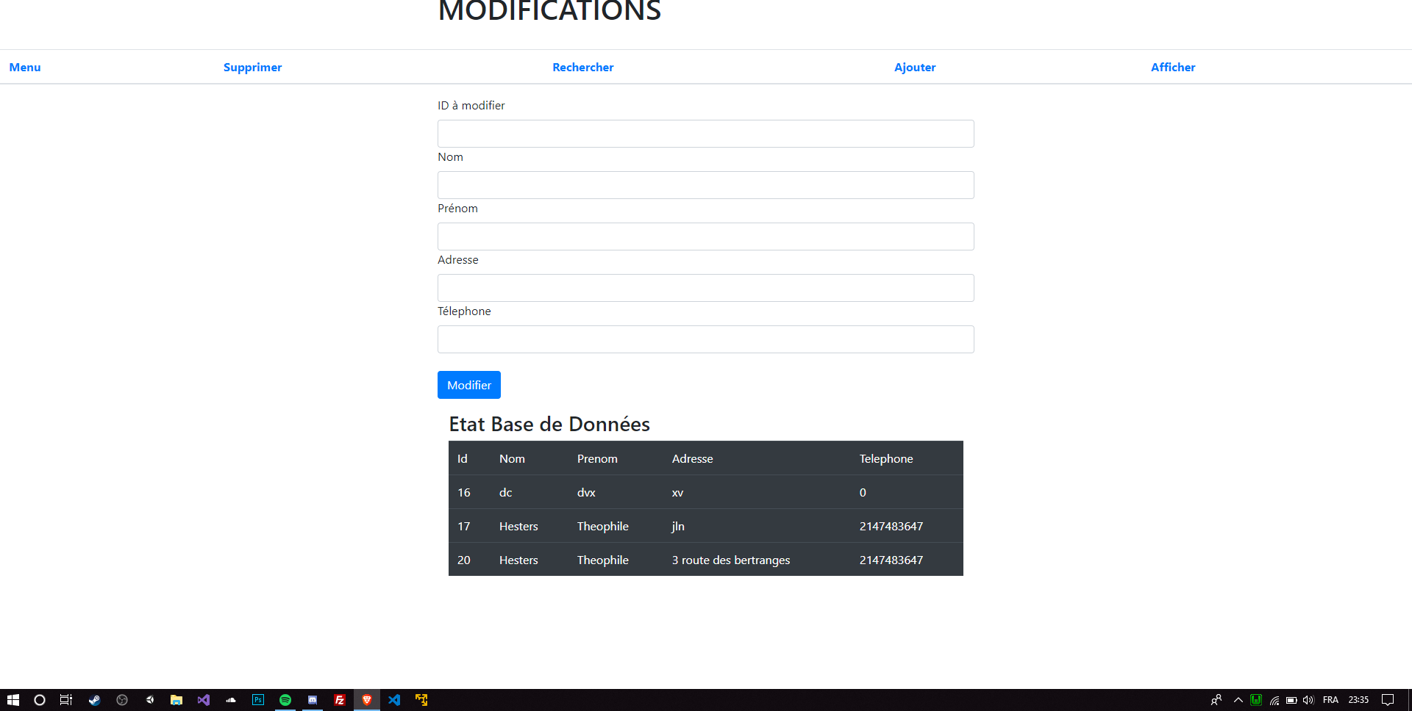
3,1,3 Rechercher

<!DOCTYPE <!DOCTYPE html>
<html>
<head>
<meta charset="utf-8">
<head>
<title>TP6</title>
<meta charset="utf-8">
<meta name="viewport" content="width=device-width, initial-scale=1">
<!-- BOOSTRAP en mode non local-->
<link rel="stylesheet" href="https://maxcdn.bootstrapcdn.com/bootstrap/4.3.1/css/bootstrap.min.css">
<script src="https://ajax.googleapis.com/ajax/libs/jquery/3.3.1/jquery.min.js"></script>
<script src="https://cdnjs.cloudflare.com/ajax/libs/popper.js/1.14.7/umd/popper.min.js"></script>
<script src="https://maxcdn.bootstrapcdn.com/bootstrap/4.3.1/js/bootstrap.min.js"></script>
</head>

<body>

<header class="masthead">
<div class="overlay"></div>
<div class="container">
<div class="row">
<div class="col-lg-8 col-md-10 mx-auto">
<div class="page-heading">
<h1>Recherche</h1>
</div>
</div>
</div>
</div>
</header>
<div class="container">
<table class="table">
<thead>
<br />
<tr>
<th><a href="modif.php">Modifier</a></th>
<th><a href="supprimer.php">Supprimer</a></th>
<th><a href="menu.php">Menu</a></th>
<th><a href="ajouter.php">Ajouter</a></th>
<th><a href="afficher.php">Afficher</a></th>
</tr>
</thead>
</table>
</div>
<div class="container">
<div class="row">
<div class="col-lg-8 col-md-10 mx-auto">
<form method="post" id="contact" enctype="multipart/form-data">
<div class="control-group">
<div class="form-group floating-label-form-group controls">
<label>Nom</label>
<input type="text" name="nom1" class = "form-control"/>
<label>Prénom</label>
<input type="text" name="pre1" class = "form-control"/>

<br />
<button type="submit" class="btn btn-primary" name="envoi" id="sendMessageButton">Rechercher </button>
</div>
</form>
</body>

</html>

<?php
$host = "localhost";
$base = "MaBase";
$table = "annuaire";
$user = "root";
$password = "";
// Si le formulaire a été envoyé
if (!empty ($_POST))
{
$nom = $_POST['nom1'];
$pre = $_POST['pre1'];

$connection = mysqli_connect($host, $user, $password, $base) or die(" ERREUR DE CONNEXION ".mysqli_connect_errno()); // Connexion à MySQL

$query = "SELECT * FROM $table
WHERE Nom='$nom';";
$result = mysqli_query($connection, $query);

echo "<div class='container'><h3 style='text-decoration: underline;'>Tableau :</h3><table class='table table-dark table-hover'><tr><td>Id</td><td>Nom</td><td>Prenom</td><td>Adresse</td><td>Telephone</td></tr></div>";
while ($line = mysqli_fetch_array($result, MYSQLI_NUM))
{
echo "<tr>";
foreach ($line as $data)
echo "<td>$data</td>";
echo "</tr>";
}

}

?>
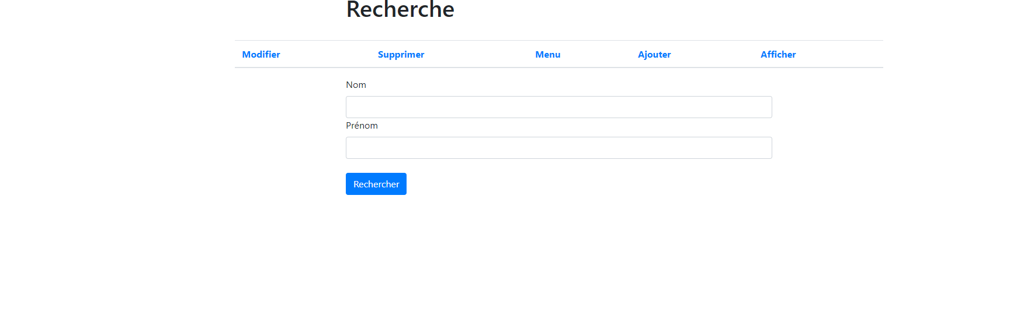
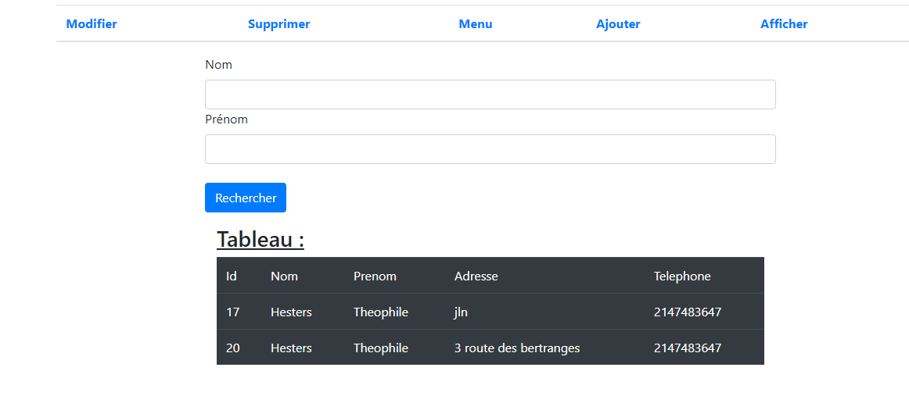

3,1,3 Supprimer

<!DOCTYPE <!DOCTYPE html>
<html>

<head>
<meta charset="utf-8">
<link rel="stylesheet" href="https://maxcdn.bootstrapcdn.com/bootstrap/4.3.1/css/bootstrap.min.css">
<script src="https://ajax.googleapis.com/ajax/libs/jquery/3.3.1/jquery.min.js"></script>
<script src="https://cdnjs.cloudflare.com/ajax/libs/popper.js/1.14.7/umd/popper.min.js"></script>
<script src="https://maxcdn.bootstrapcdn.com/bootstrap/4.3.1/js/bootstrap.min.js"></script>

</head>

<body>
<header class="masthead">
<div class="overlay"></div>
<div class="container">
<div class="row">
<div class="col-lg-8 col-md-10 mx-auto">
<div class="page-heading">
<h1>Supprimer</h1>
</div>
</div>
</div>
</div>
</header>
<div class="container">
<table class="table">
<thead>
<br />
<tr>
<th><a href="modif.php">Modifier</a></th>
<th><a href="menu.php">Menu</a></th>
<th><a href="rechercher.php">Rechercher</a></th>
<th><a href="ajouter.php">Ajouter</a></th>
<th><a href="afficher.php">Afficher</a></th>
</tr>
</thead>
</table>
</div>
<div class="container">
<div class="row">
<div class="col-lg-8 col-md-10 mx-auto">
<form method="post" id="contact" onsubmit="setTimeout(function(){window.location.reload();},10)" enctype="multipart/form-data" enctype="multipart/form-data">
<div class="control-group">
<div class="form-group floating-label-form-group controls">
<label>ID à supprimer</label>
<input type="text" name="choix"class = "form-control"/>
<br />
<button type="submit" class="btn btn-primary" name="envoi" id="sendMessageButton">Supprimer </button>
</form>
</body>

</html>
<?php

$host = "localhost";
$base = "MaBase";
$table = "annuaire";
$user = "root";
$password = "";

$connection = mysqli_connect($host, $user, $password, $base) or die("Erreur de connexion au serveur MySQL : ".mysqli_connect_errno());

$query = "SELECT * FROM $table";

$result = mysqli_query($connection, $query) or die("Echec de la requête suivante :<br />".$query);

echo "<div class='container'><br /><table class='table table-dark table-hover'><tr><td>Id</td><td>Nom</td><td>Prenom</td><td>Adresse</td><td>Telephone</td></tr></div>";

while ($line = mysqli_fetch_array($result, MYSQLI_NUM))
{
echo "<tr>";
foreach ($line as $data)
echo "<td>$data</td>";
echo "</tr>";
}

echo "</table>";

mysqli_free_result($result);
mysqli_close($connection);
if (!empty ($_POST))
{
$choix = $_POST['choix'];

$connection = mysqli_connect($host, $user, $password, $base) or die(" ERREUR DE CONNEXION ".mysqli_connect_errno()); // Connexion à MySQL

$query = "DELETE FROM `$table` WHERE `id`=$choix";;
$result = mysqli_query($connection, $query);

}

?>

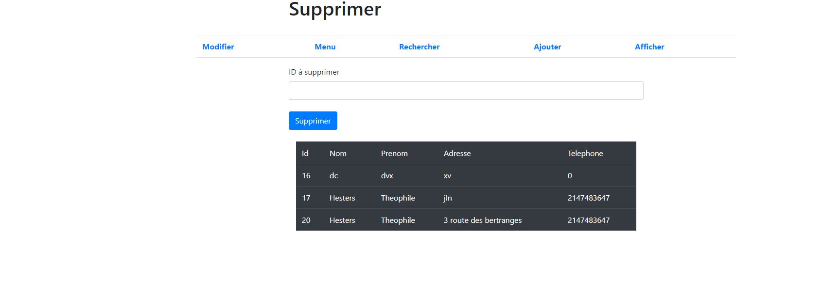

3,1,3 Ajouter

<!DOCTYPE <!DOCTYPE html>
<html>
<head>
<head>
<title>TP6</title>
<meta charset="utf-8">
<meta name="viewport" content="width=device-width, initial-scale=1">
<!-- BOOSTRAP en mode non local-->
<link rel="stylesheet" href="https://maxcdn.bootstrapcdn.com/bootstrap/4.3.1/css/bootstrap.min.css">
<script src="https://ajax.googleapis.com/ajax/libs/jquery/3.3.1/jquery.min.js"></script>
<script src="https://cdnjs.cloudflare.com/ajax/libs/popper.js/1.14.7/umd/popper.min.js"></script>
<script src="https://maxcdn.bootstrapcdn.com/bootstrap/4.3.1/js/bootstrap.min.js"></script>
</head>
<meta charset="utf-8">

</head>
<body>
<header class="masthead">
<div class="overlay"></div>
<div class="container">
<div class="row">
<div class="col-lg-8 col-md-10 mx-auto">
<div class="page-heading">
<h1>AJOUTER</h1>
</div>
</div>
</div>
</div>
</header>
<div class="container">
<table class="table">
<thead>
<br />
<tr>
<th><a href="modif.php">Modifier</a></th>
<th><a href="supprimer.php">Supprimer</a></th>
<th><a href="rechercher.php">Rechercher</a></th>
<th><a href="menu.php">Menu</a></th>
<th><a href="afficher.php">Afficher</a></th>
</tr>
</thead>
</table>
</div>
<form method="post" enctype="multipart/form-data" id="contact" onsubmit="setTimeout(function(){window.location.reload();},10)" enctype="multipart/form-data">
<div class="container">
<div class="row">
<div class="col-lg-8 col-md-10 mx-auto">
<form method="post" id="contact" enctype="multipart/form-data">
<div class="control-group">
<div class="form-group floating-label-form-group controls">
<label>Nom</label>
<input type="text" name="nom1" class = "form-control"/>
<label>Prénom</label>
<input type="text" name="pre1" class = "form-control"/>
<label>Adresse</label>
<input type="text" name="adr1" class = "form-control"/>
<label>Télephone</label>
<input type="text" name="tel1" class = "form-control"/>
<br />
<button type="submit" class="btn btn-primary" name="envoi" id="sendMessageButton">Modifier</button>
</div>
</form>
</body>
</html>

<?php
$host = "localhost";
$base = "MaBase";
$table = "annuaire";
$user = "root";
$password = "";
// Si le formulaire a été envoyé
if (!empty ($_POST))
{
$nom = $_POST['nom1'];
$pre = $_POST['pre1'];
$adr = $_POST['adr1'];
$tel = $_POST['tel1'];

$connection = mysqli_connect($host, $user, $password, $base) or die(" ERREUR DE CONNEXION ".mysqli_connect_errno()); // Connexion à MySQL

$query = "INSERT INTO annuaire (Nom,Prenom,Adresse,Telephone) values('$nom','$pre','$adr','$tel')";
$result = mysqli_query($connection, $query);

}

?>

